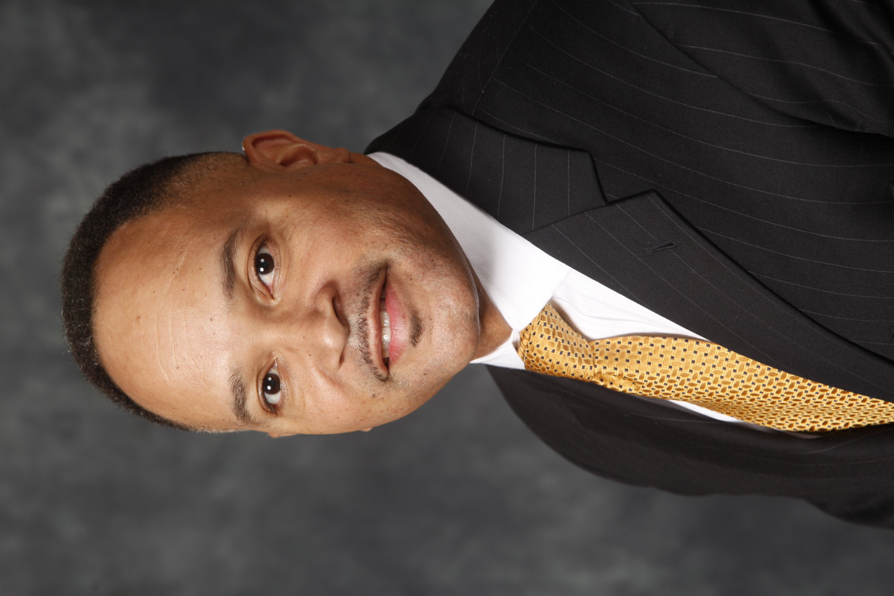 | Wilson H. Friend  Director, Account Information Services,  Altria Client Services

Wilson H. Friend currently serves the role of Director, Account Information Services for Altria Client Services (ALCS). In his current role, he is responsible for enhancing business process and leverage technology to improve productivity and capability for Altria Group Distribution Company (AGDC). In addition, he leads the development of innovative solutions to provide category information and insights to support brand program execution.

Prior to this, Wilson was Director of Business Process and Technology for Altria Group Distribution Company. He managed the delivery of technology and trade program solutions for the AGDC Field Sales Organization. Wilson also held the position of Director of Database and Digital Delivery for Altria Consumer Engagement Services. He managed all Digital brand programs across the Altria Operating Companies, which include Marlboro.com, Copenhagen.com, Skoal.com, RedSeal.com and Black&Mild.com). Wilson was accountable for managing and growing the over 33MM ATC Database to connect Altria Operating Companies brands with Adult Tobacco Consumers.

In 2007, Wilson held the position Director of Sales for the Mid-Atlantic field sales force where he was responsible for building trade partnerships and execution of marketing and trade programs at over 12,000 retail locations.

Wilson joined the company in 1993 and has held several leadership positions since receiving his Bachelor of Business Administration degree from James Madison University in 1992. From 2004-2006 Wilson worked as a Manager for the Customer Service & Merchandising department. In 2006, he was appointed Director, Business Process and Technology. While working in the sales organization for Philip Morris USA, Wilson gained extensive experience in managing sales and distribution processes as well as significant leadership in organizational development and building processes that support sales activities.

